This document is to be used in conjunction with the official AWS QuickStart Reference document provided by Amazon. We have created this Dummies guide to help walk through creation of dependencies mentioned in the document as well as common issues.

https://s3.amazonaws.com/quickstart-reference/redhat/openshift/latest/doc/red-hat-openshift-on-the-aws-cloud.pdf

Pre-requisites:

You will need a few things before you start to use the AWS Quick Start process.

1) You will need an account on AWS. The OpenShift installs are not able to use free credits, so you will need to set up pay as you go or have some available credits.
2) Create an IAM role that will be use for this deployment.
- From the AWS console, select IAM Management.
- From the menu on the left hand side menu select Roles > Create Role .
- Choose Cloud Formation as the role type from the list of options and select Next Permissions from the bottom left of the screen.
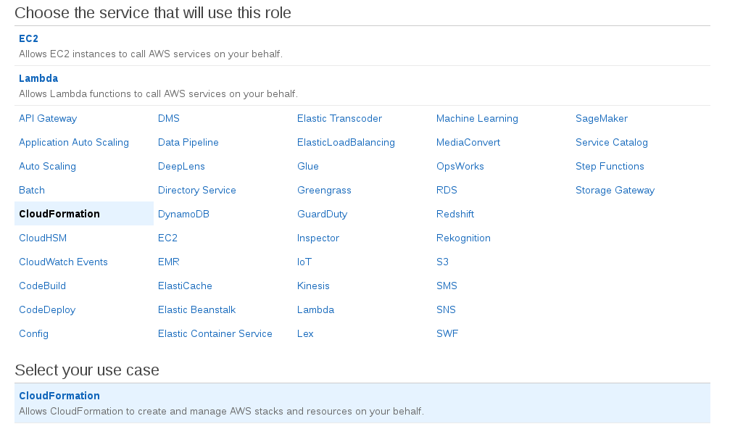
- Give AdministratorAccess permissions and select Next:Review
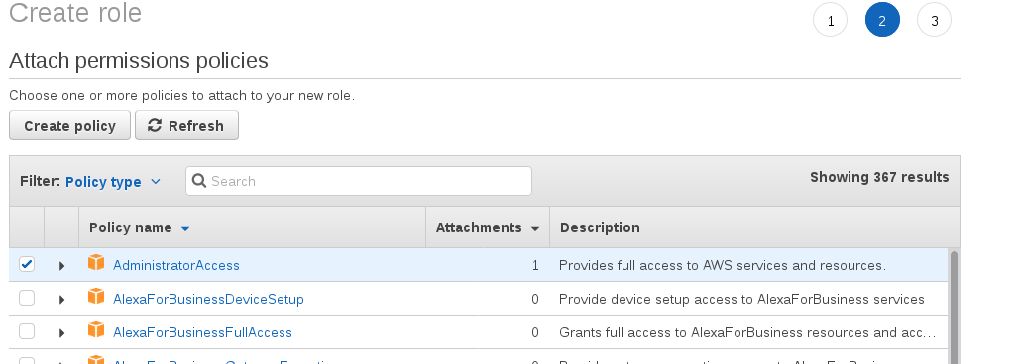
- Give your role a name for example “ocp-aws” and select Create Role.

Sample Role
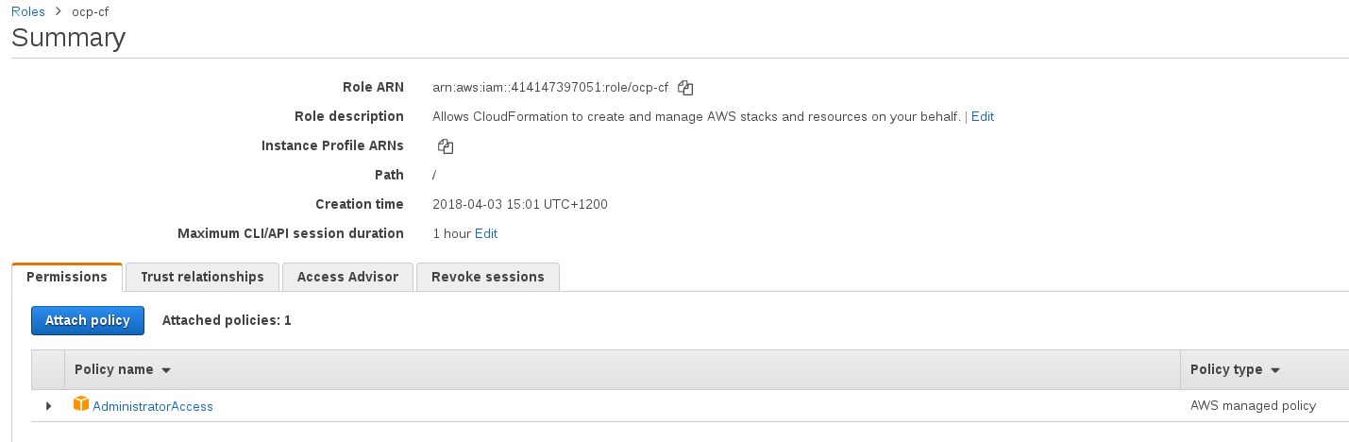

Note: Under your IAM Management Page make sure that you have not deleted your root access keys. Make sure you still have a warning exclamation mark beside these security status items. If you delete the root access keys the stack will hang during the Ansible Config Server process and eventually time out and fail.
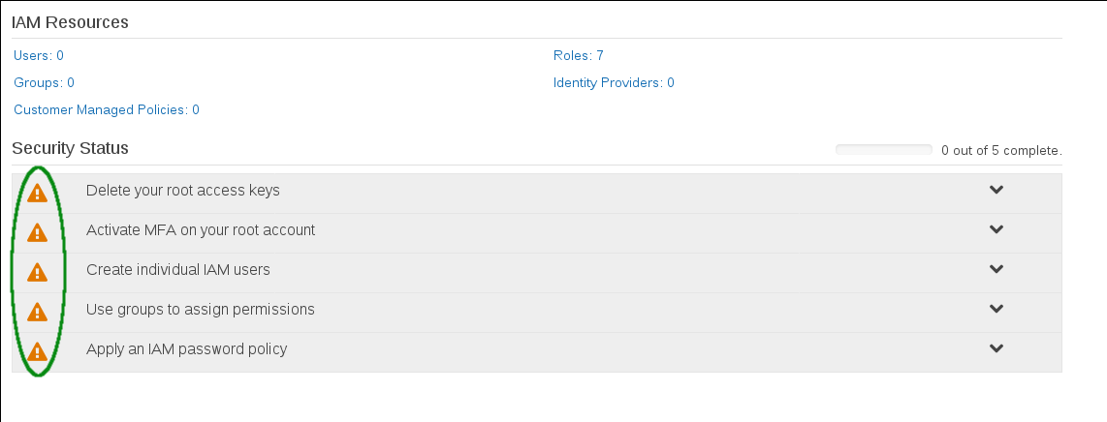

2. Create a Route53 hosted zone with a valid registrar. You can do this by two ways
1: Attach you external DNS to your AWS VPC.
2: Purchase a new Domain name from AWS.
For the purposes of this example we will use the easiest path which is to purchase a new Domain.

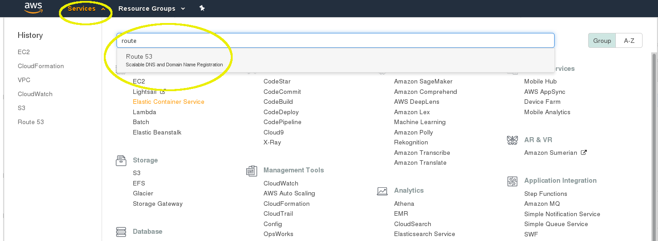
From the AWS Console, navigate to Route 53 management (Choose Services then search for Route 53 and select from the drop down OR select from the list of menu of services page it can be found under Networking & Content Delivery.).

Go to Domain Registration and register a domain. Follow the process to register your domain it will normally say it takes up to 3 days but it is usually completed within an hour.
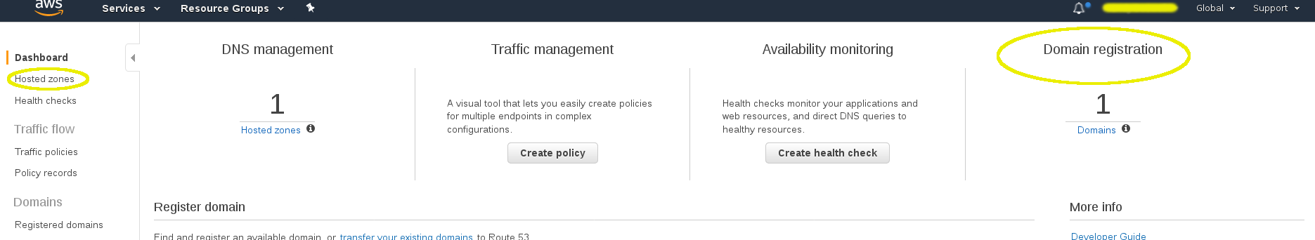

Once you have the new domain, go to the AWS console and navigate to management for Route 53, select Hosted Zones from the left menu. Because you created your Domain through AWS then the hosted zone will already be created for you. From this page you will need the Hosted Zone ID for the CloudFormation template later in this process.

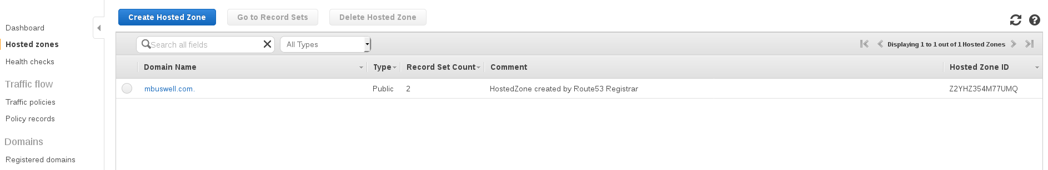

3) Make sure you have a valid OCP subscription that you can use. You will need the username, password and subscription Pool ID. You will need to get the Pool ID to complete the cloudformation template.

You can either use your own corporate subscription, a evaluation subscription provided by Red Hat, a developer subscription by signing up to developer.openshift.com or get a trial subscription at https://www.redhat.com/wapps/eval/index.html?evaluation_id=1026

To find out the Pool ID you have options:
Log into the customer portal with your subscription username and password.
- Login to https://access.redhat.com
- Click on "My Subscriptions"
- Click on "Active" just below "Subscription Utilization"
- Find the Subscription Name that you would like to use
- Click on the Subscription Number for the subscription you would like to use
PoolId is displayed in the "Pool IDs section"

From a subscribed RHEL server you can use this command (see https://access.redhat.com/solutions/2434941):

#subscription-manager list --available --all

Note: the AWS Quick Start Read Me suggest if you do not have a subscribed RHEL instance already then run one up in AWS subscribe it and run the query command there. Details at https://github.com/dougtoppin/quickstart-redhat-openshift/blob/master/README.md OR
https://s3.amazonaws.com/quickstart-reference/redhat/openshift/latest/doc/red-hat-openshift-on-the-aws-cloud.pdf

4) Create an SSH Key. From the AWS Services select EC2. Under Network & Security select Key Pairs. Choose to Create Key Pair and follow the instructions.

Once you have all of the pre-requisites you can start the process on AWS as follows:

1) Go to https://aws.amazon.com/quickstart/architecture/openshift/
Select Deploy OpenShift on to a New VPC

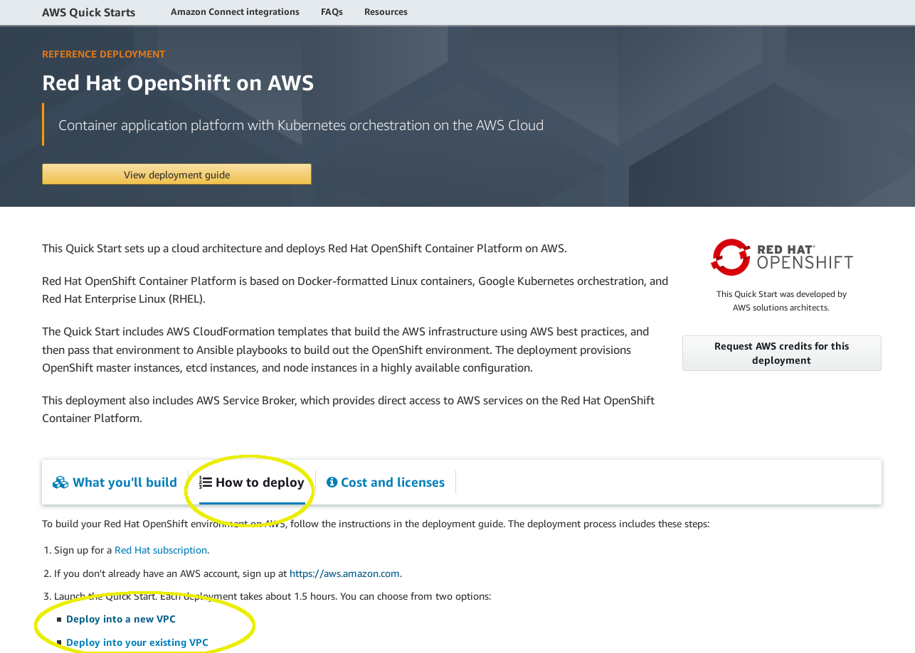

2) On the select Template page just hit Next leaving all the defaults
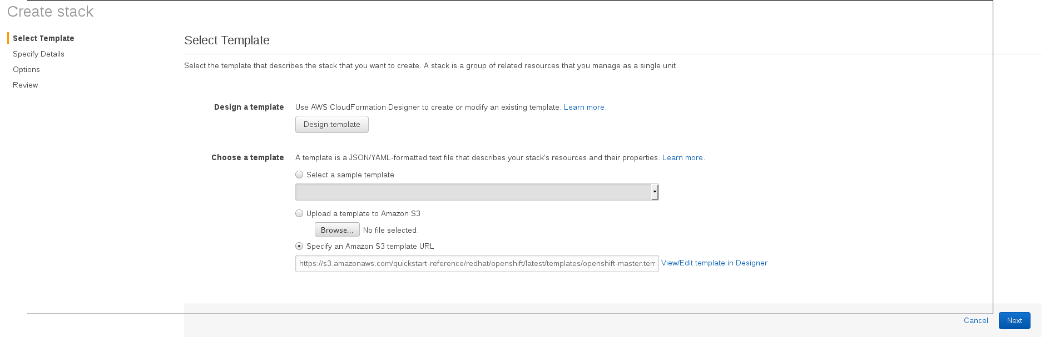
You can see the region in the top right menu bar. By default it may be somewhere in the United States as in my example, but you can change it at this point in time to another region Sydney for example.
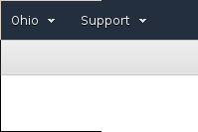

3) On the Specify Details page you will need to fill in your information. You can leave everything default with the exception of the following:

Network Configuration
AvailabilityZones - Select three availability zones as offered by the dropdown on this field. The available AZs will be tied to the Region that is selected for this service. If you want to change that now you can do so, you will be returned to the previous step after changing and simply hit Next again to come back to this page.
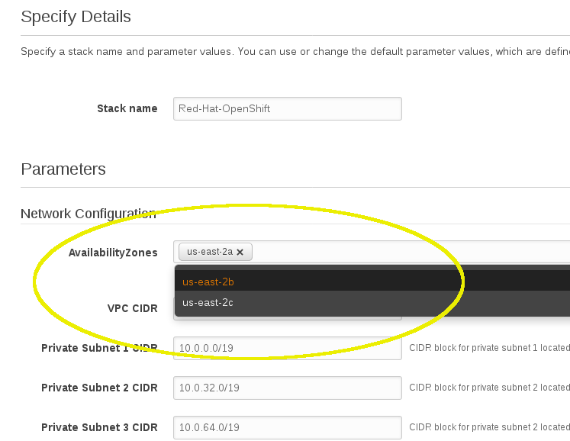

CIDRs - don’t change any of these unless you are sure what you are doing. The defaults are fine.

Allowed External Access CIDR (OCP UI) and Allowed External Access CIDR (OCP Router): Set these to 0.0.0.0/0 to allow all access alternatively set specific access.

DNS Configuration
Domain Name : Enter the domain you just created
Route 53 Hosted Zone ID : Enter the Hosted Zone ID from the Hosted Zones created during the prerequisites
Subdomain Prefix : Add a subdomain here for example ‘ocpaws’

Amazon EC2 Configuration
SSH Key Name : Select a key from the drop down

OpenShift Nodes Configuration
Leave the defaults.
OpenShift UI Password : Enter what password you would like to use for the OpenShift UI

OpenShift Feature Configuration
AWS Service Broker : Must be left Enabled else the template will error.

Red Hat Subscription Information
Enter all your subscription details including the Pool ID.

Select Next.

On the OPTIONS page that follows, you can leave all the defaults. Select the ADVANCED tab to expand the options here. Observe the Termination Protection option and Enable it. Observe the Rollback on Failure option and set this to No. This will prevent your stack from being deleted if there is a problem during the install and allows you to troubleshoot more easily.

Select Next.

On the following page at the bottom select the Acknowledgement and select Create.

You can monitor the process, expect it to take about an hour.

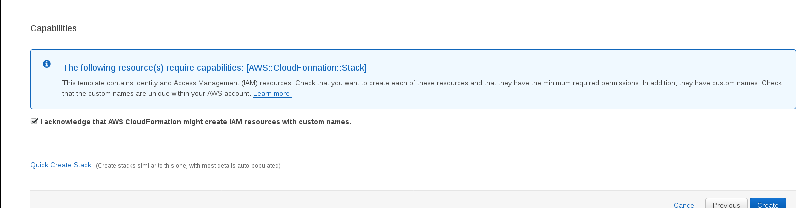

At the end of the process you should see details of how to access the OpenShift Web Console under

Once the install has completed
- Add admin rights to the ‘admin’ Web Console user. (This allows the admin web console user to see all cluster containers through the web console rather than only via the command line.)
Log into your Bastion Host which is the EC2 instance named ansible-configserver
sudo su -
ansible masters -m shell -a "oc adm policy add-cluster-role-to-user cluster-admin admin”

Openshift Install Using Openshift-Contrib on AWS
This is another way of installing OpenShift on AWS using an ansible playbook.

Reference: https://github.com/openshift/openshift-ansible-contrib

Assumptions:
- You have a Linux workstation that you will be using for this deployment.
- This document will not cover the instruction on how to create an AWS account. It is assumed that you have an active AWS account.
- This document assume that you have an active Red Hat Openshift Container Cluster subscription. During the deployment, you’ll need to provide your Red Hat Subscription username, password and pool ID
- That this deployment is not to be used for production implementation.
- As of this writing this deployment procedure only work for Openshift 3.7.x

Pre-requisites:
- Get your AWS_ACCESS_KEY_ID and AWS_SECRET_ACCESS_KEY
  - to get your AWS Access Key follow this procedure: https://docs.aws.amazon.com/cli/latest/userguide/cli-chap-getting-started.html
- Create a Route53 hosted zone with a valid registrar. You can do this by two ways
- Attach you external DNS to your AWS VPC.
- Purchase a new Domain name from AWS.
Note: For the purposes of this example we will use the easiest path which is to purchase a new Domain.

From the AWS Console, navigate to Route 53 management. Go to Domain Registration and register a domain. Follow the process to register your domain it will normally say it takes up to 3 days but it is usually completed within an hour.

Once you have the new domain, go to the AWS console and navigate to management for Route 53, select Hosted Zones from the left menu. Because you created your Domain through AWS then the hosted zone will already be created for you. From this page you will need the Hosted Zone ID for the CloudFormation template later in this process.

- Due to the installations use of a bastion server the ssh config must be modified. In this example the domain name I registered on AWS Route53 is makeaangayon.com.

Create an ssh config file and put this on your home directory:

$vi ~/.ssh/config
Host *.makeaangayon.com << your route53 domain
ProxyCommand ssh ec2-user@bastion -W %h:%p
IdentityFile ~/.ssh/aws_ocp_contrib

Host bastion
Hostname bastion.makeaangayon.com << your route 53 domain
user ec2-user
StrictHostKeyChecking no
ProxyCommand none
CheckHostIP no
ForwardAgent yes
IdentityFile ~/.ssh/aws_ocp_contrib

4. Create a Github Organization. This is needed for the next prerequisite. You need to make sure that the Oauth application is attached to this organization.
Procedure: https://www.sap.com/developer/tutorials/webide-github-creating-org.html

5. For the sake of this test document, we will use the GitHub authentication, the default authentication mechanism used for this reference architecture.
Create an Oauth Application in Github. Follow the procedure below:
https://developer.github.com/apps/building-oauth-apps/creating-an-oauth-app/

Homepage URL: https://openshift-master.makeaangayon.com
Authorization callback URL: https://openshift-master.makeaangayon.com/oauth2callback/github

6. Find the AMI ID of your AWS account. You will use this on information on the python script that will invoke cloudformation script that create the AWS OCP stack. Below is the procedure to find the AMI ID attached to your AWS account.
https://docs.aws.amazon.com/AWSEC2/latest/UserGuide/finding-an-ami.html

Deployment Steps:
- Download/clone the latest version of Openshift-ansible-contrib
https://github.com/openshift/openshift-ansible-contrib
- Subscribe your Workstation to the following Red Hat channels:
$ subscription-manager repos --enable rhel-7-server-optional-rpms
$ subscription-manager repos --enable rhel-7-server-ose-3.6-rpms
$ subscription-manager repos --enable rhel-7-fast-datapath-rpms
$ yum -y install atomic-openshift-utils ansible openshift-ansible-playbooks
$ rpm -Uvh https://dl.fedoraproject.org/pub/epel/epel-release-latest-7.noarch.rpm
- Install the following software:
$ yum -y install python2-boto \
pyOpenSSL \
git \
python-netaddr \
python-six \
python2-boto3 \
python-click \
python-httplib2 \
python-passlib \
httpd-tools \
java-1.8.0-openjdk-headless

- Export your AWS Keys:
export AWS_ACCESS_KEY_ID=foo
export AWS_SECRET_ACCESS_KEY=bar

5. Update the AMI image on this file. Use the information you gathered base on pre-req #6
/root/openshift-ansible-contrib/reference-architecture/aws-ansible/ose-on-aws.py

Reference below:

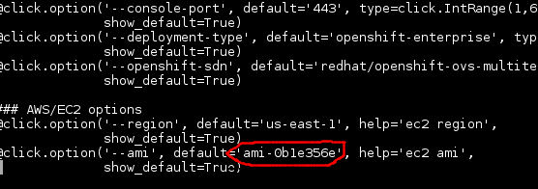

6. You can then run this command to start building your OCP environment:

~openshift-ansible-contrib/reference-architecture/aws-ansible/ose-on-aws.py --keypair=aws_ocp_contrib --rhsm-user=username --rhsm-password=password--public-hosted-zone=makeaangayon.com --rhsm-pool="Red Hat OpenShift Container Platform" --github-client-secret=d1353063393257d2052aabb3c3b5ae68b4f13255 --github-organization=openshift --github-organization=malocoibajay --github-client-id=2ef02f1759c458fc11e3 --region=us-east-2

7. Access the UI by going to https://your.domain.com

